Light Switches and Outlet Covers
“Clap on, clap off” Remember that tune
In one of our previous blogs we discussed the importance of great lighting in a home/property for sale/rent and one feature most everyone misses in that equation is the “Light Switch or Outlet Cover”.
As with all small details this one is easily missed by most people, yet it plays an important role on creating a lasting impression of your property. Say for example you are about to turn on the lights in a room/closet or bathroom and you look at the switch and it is dated, yellow and possible cracked…EW. You think to yourself when be the last time these people did any repairs to this house?
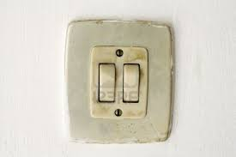
Changing outlet covers is very inexpensive and can be done by most anyone with some home repair experience; yes you can probably do it yourself. This gives you an opportunity not only beautifies the outlet/switch but also update it to current requirements.
The following is to be considered when buying/installing new switches:
Color/shape: White always works, but if you have a more antique look in your property choose one that suits the décor. Modern rectangular shape with most common and is very inexpensive, although just like with the color you can choose a shape that best suits the décor of the room.
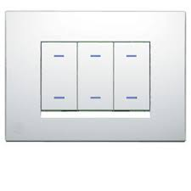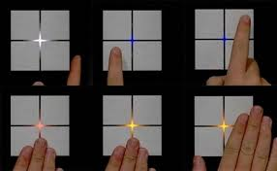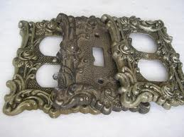
Safety: all outlets near sinks/water should be GFI (also known as a ground-fault circuit interrupter, or GFCI) that help protect against electrical shock. Optional: Tamper-resistant receptacles, have internal shutters that make it difficult for children to insert objects, a feature of this type maybe of importance to families with children looking at your property.
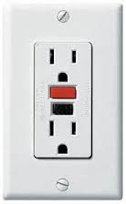
Functionality: One other feature to consider is dimmers on the light switches, if you have a very limited budget you may want to place these only in common area such as living, family or dining room. 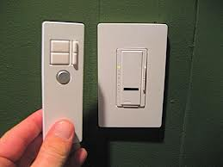
Remember, it’s all in the details.

Happy Selling$$$$

